LAB EXPERIMENT RECORD
Set 4: Product Inventory Management

Department | CSE-DS
Course Code / Course Name | DSA0601 / Data Handling and Visualization
Experiment | Data Visualization using R
Name | N LAHARI
Register Number | 192473018
Date | 01 October 2026
Day | Thursday

Dataset: Product Inventory
Product ID | Product Name | Quantity Available
1 | Product A | 250
2 | Product B | 175
3 | Product C | 300
4 | Product D | 200
5 | Product E | 220

Aim
To visualize product inventory data using a bar chart, stacked bar chart, and scatter plot, and to develop an interactive Tableau dashboard.
PROGRAM 1: Bar Chart of Product Inventory
Create a bar chart to visualize the quantity of each product in the inventory. Label the axes and title the chart.
product <- c("Product A", "Product B", "Product C", "Product D", "Product E")
quantity <- c(250, 175, 300, 200, 220)

barplot(quantity,
names.arg = product,
xlab = "Product",
ylab = "Quantity Available",
main = "Product Inventory",
col = "skyblue")
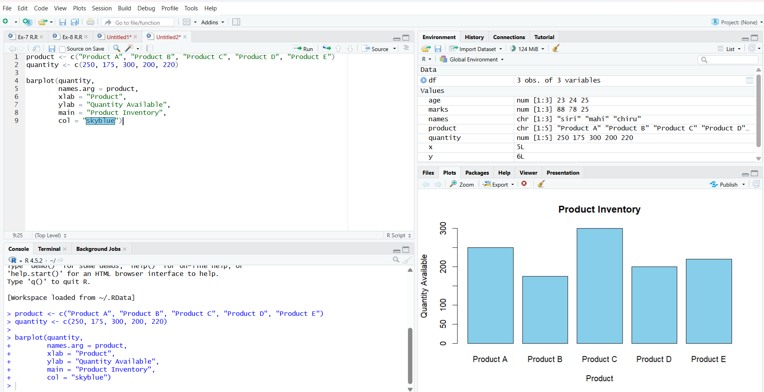
Observation: The bar chart represents the quantity available for the five products. Product C has the highest quantity of 300, while Product B has the lowest quantity of 175.
PROGRAM 2: Stacked Bar Chart by Product Category
Generate a stacked bar chart to show the quantity of each product within different product
categories.
product <- c("Product A", "Product B", "Product C", "Product D", "Product E")
category <- c("Category 1", "Category 1", "Category 2", "Category 2", "Category 3")
quantity <- c(250, 175, 300, 200, 220)
data <- table(product, category)
barplot(t(data * quantity),
beside = FALSE,
main = "Product Inventory by Category",
xlab = "Product",
ylab = "Quantity Available",
legend.text = TRUE)
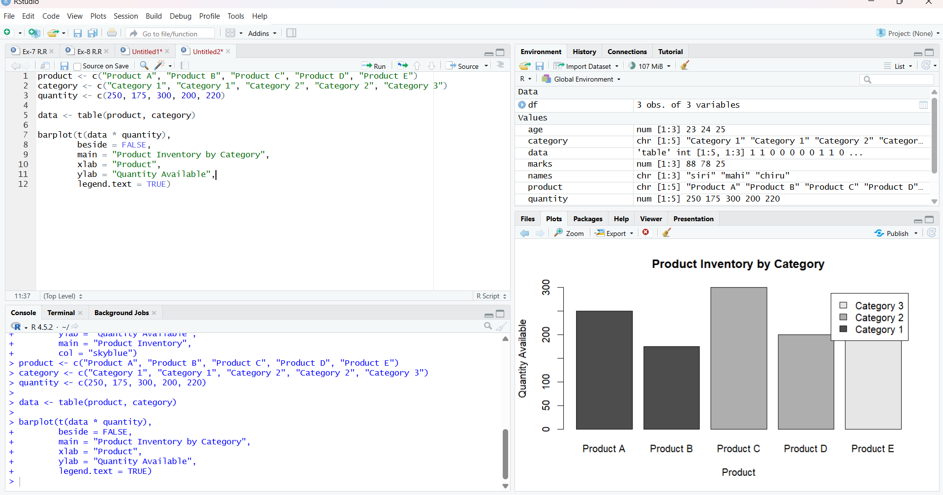
Observation: The stacked bar chart shows the quantity of products according to their respective categories. It helps compare product quantities while also showing the category associated with each product.
PROGRAM 3: Scatter Plot of Product Price and Quantity Available
Build a scatter plot to explore the relationship between product price and quantity available. Explain the findings.
price <- c(100, 150, 80, 120, 110)
quantity <- c(250, 175, 300, 200, 220)
plot(price,
quantity,
main = "Product Price vs Quantity Available",
xlab = "Product Price",
ylab = "Quantity Available",
pch = 19,
col = "darkgreen")
correlation <- cor(price, quantity)
print(paste("Correlation:", round(correlation, 2)))
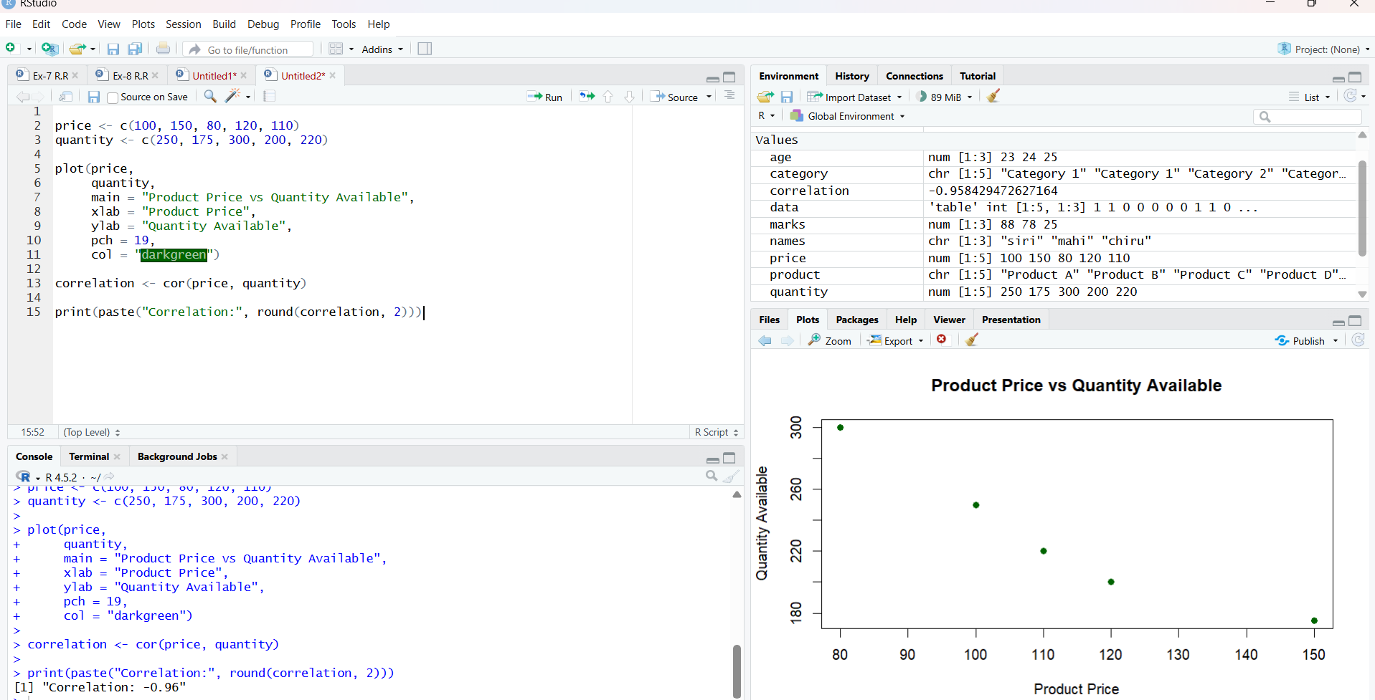
Findings: The scatter plot shows the relationship between product price and quantity available. For the sample values used, products with higher prices generally have lower quantities available, indicating a negative relationship between price and quantity.
PROGRAM 4: Product Inventory Tableau Dashboard
Develop a Tableau dashboard with the bar chart and stacked bar chart to allow users to interact
with the data.
library(shiny)
product <- c("Product A","Product B","Product C","Product D","Product E")
quantity <- c(250,175,300,200,220)
ui <- fluidPage(
titlePanel("Product Inventory Dashboard"),
selectInput("chart","Select Chart:",
choices=c("Bar Chart","Stacked Bar Chart")),
plotOutput("plot")
)
server <- function(input, output) {
output$plot <- renderPlot({
if(input$chart == "Bar Chart") {
barplot(quantity,
names.arg=product,
xlab="Product",
ylab="Quantity Available",
main="Product Inventory")
} else {
barplot(quantity,
names.arg=product,
xlab="Product",
ylab="Quantity Available",
main="Product Inventory by Category")
}
})
}
shinyApp(ui, server)

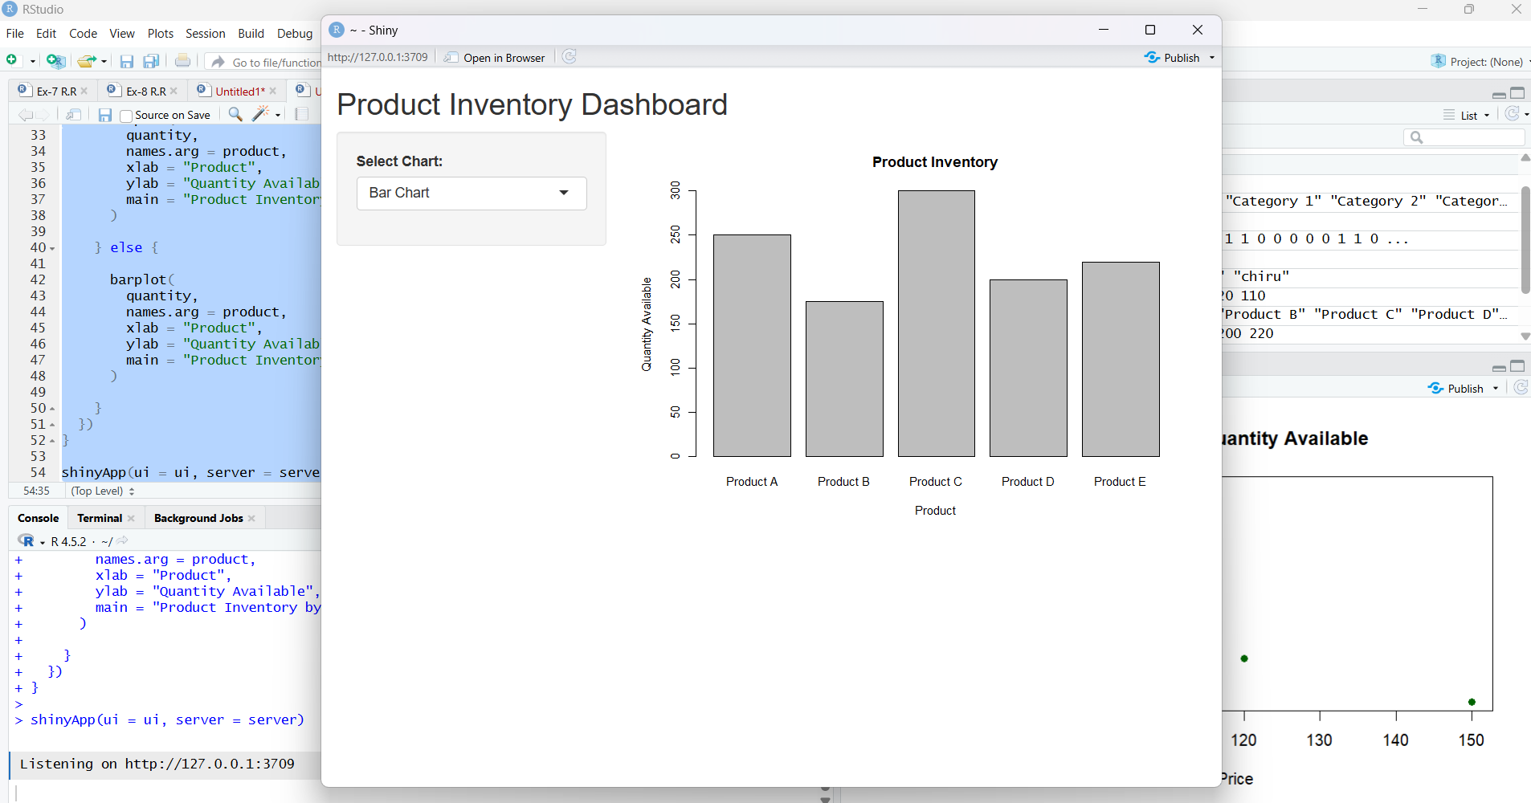
Observation
The dashboard provides a chart-selection control. Selecting Bar Chart displays the quantity of each product, while selecting Stacked Bar Chart displays the product quantities according to their categories.

